**1. Project Title:**

Improving techniques for estimating abundance and habitat use in nearshore marine habitats using environmental DNA.

**2. Investigators:**

A. Ole Shelton (NWFSC), Ryan Kelly (University of Washington), Correigh Greene (NWFSC), Linda Park (NWFSC)

**3. Project Duration and Requested Funds:**

2 years, 112.5K per year.

**4. Summary:**

Organisms of all kinds shed cells containing diagnostic DNA into the environment, which can be recovered and assigned to a taxon based upon its match to known sequences. Because DNA degrades under most ambient environmental conditions—the half-life of DNA in fresh- and saltwater is approximately 24-48 hours (*1,2*)—this environmental DNA (eDNA) provides a snapshot of the species recently present in the sampled habitat. However, while it is widely accepted that DNA can be collected and identified from a range of environmental samples, connecting field collections of eDNA with abundance surveys remains largely unexplored.

Here, we propose to develop eDNA survey methods to quantify fish communities (with a focus on salmon, herring, and smelt species) in a nearshore estuarine habitat in Puget Sound. To compare the efficacy of eDNA and traditional methods, we will collect water samples in parallel with collections made via three traditional net sampling methods, targeting nearshore fish communities that provide a range of spatial sampling scales (from meters to 100s of meters). We will use both quantitative PCR (qPCR) and massively parallel DNA sequencing technologies to provide eDNA data. We will then apply a newly developed statistical framework to provide field estimates of the relationship between species abundance and eDNA. Our replicated sampling design—using three field methods at three spatial scales—provides an opportunity to understand the appropriate spatial scale for eDNA sampling, and the potential value and pitfalls of eDNA surveys for understanding patterns of fish abundance.

**5. Scope, Objectives, Merit:**

Early life-history is a critical period for most commercially important fishes. For anadromous salmonids, the transition from freshwater to the marine environment is a key determinant of marine survival and fisheries productivity. Similarly, ecologically important forage fish (e.g. herring and smelt) use nearshore and estuarine habitats as spawning and rearing grounds. Thus, accurate estimates of fish abundance in nearshore estuarine areas are critical to understanding early life-history survival and play an important, poorly understood role in driving stock assessment models. However, estimates of fish abundance in the nearshore habitats are difficult and expensive to obtain using traditional sampling methods; shallow water and vegetation interfere with acoustic surveys, turbid water often hinders visual surveys, and the presence of vegetation and other structures restricts the efficacy of some net survey techniques. Nonetheless, estimating salmon and other fish species’ abundance is especially important in light of (a) continued loss of foundational vegetated habitats such as seagrass beds, salt marshes, and other coastal wetlands, and (b) restoration efforts intended to mitigate such losses. Assessing the importance of nearshore habitats to salmonids and forage fish —and the success of nearshore restoration efforts in particular—requires efficient methods for quantifying abundance in these habitats. **We propose to apply recently developed environmental DNA (eDNA) survey techniques to assess the fish communities across three habitats used at different points during the salmon migration from freshwater to the ocean.** We will characterize the abundance of salmonids and other commercially valuable and ecologically important fish in three distinct estuarine habitats; these three habitats offer the additional benefit of comparing results across three different spatial sampling techniques. If successful, this project would adapt a rapidly-developing, innovative technology that could inform stock assessments nationwide.

This project has three main objectives: **(1)** Validate and improve eDNA methods for rapidly detecting the occurrence and abundance of ecologically important coastal fish; **(2)** Assess the efficacy of eDNA methods by comparing estimates of occurrence and abundance from traditional net sampling and eDNA methods across three existing sampling methodologies; **(3)** Compare costs and relative benefits of eDNA methodologies relative to traditional sampling methods. The project will improve abundance estimates for species that are ecologically and commercially important but difficult to survey, including juvenile salmon (*Oncorhynchus* spp.) and forage fish (e.g. herring (*Clupea pallasi*) and smelt (family *Osmeridae*)). Herring and smelt have been estimated as the most numerically abundant fish but exhibit recent declines, while Chinook salmon populations in this river system are ESA-listed, but suffer from poor quantification (*3,4*).

We will focus on developing rigorous eDNA methods in a single estuary and will compare results from eDNA samples with three widely used net sampling techniques (Fyke net, beach seine, surface trawl). Each of these sampling methods occurs in distinct habitats and samples different cumulative areas (increasing from the scale of ~1 to 100s of meters); as such, we expect the match between eDNA and net sample to vary with each sampling method. Concordance should be highest for Fyke nets and lowest for surface trawls. However, the rate at which the concordance between eDNA and sampling scale changes is itself a useful metric because it has direct implications for the appropriate scale at which to apply eDNA methods in the field. Beyond individual sample-to-sample comparisons, we will calculate aggregative measures of fish density from traditional and eDNA methods. Such sample aggregation is a critical step in the development of abundance indices that feed directly into most stock assessments. Thus our research plan provides information on two pressing questions for the future use of eDNA in stock assessments: (1) at what spatial scale can eDNA accurately reflect local abundance? and (2) can eDNA provide integrated metrics of abundance on scales useful for management?

Developing quantitative applications, such as we propose here, is the key next step in the evolution of eDNA into a practically useful tool, pointing the way to such uses as stock assessments, counts of endangered or invasive species, and other quantitative surveys for species and communities of interest. Accordingly, the work we propose here applies NMFS-wide, and additionally has benefits that will ramify outside of the agency. For example, USGS and State agencies have expressed interest in surveying salmonids and protected species with eDNA (pers. comm.), work that the proposed project would directly inform. **In short, we propose to lay the necessary methodological and quantitative groundwork to make eDNA useful for NMFS and others.** An added benefit of eDNA methods for NMFS is the potential to bring down the future costs of survey work: on a per-sample basis, eDNA appears likely to become cheaper than many traditional sampling methods. Finally, the project would contribute to a durable collaboration between the NWFSC and UW researchers in the College of the Environment, leveraging NMFS’s financial and human resources.

**6. Defined Uncertainties:**

The idea that one can sample a volume of water, sequence the DNA present, and report what species are living nearby is widely accepted among microbial biologists (e.g *5,6*). For fisheries ecologists that have historically use manual count data, eDNA has quickly become a potential new avenue through which to examine the world, but has yet to come into common practical use because of unknowns surrounding quantification. Preliminary data in hand demonstrate eDNA’s feasibility, appropriate spatial scale, and suitable taxonomic breadth for the proposed project.

To date, no eDNA study has explicitly linked biomass to field estimates under field conditions and very few have linked them under controlled laboratory conditions (*7*). Instead, most researchers have either asserted that the proportion of sequences observed from environmental samples mirrors the abundance (either count or biomass) of physically collected individuals (*6*). While these assertions may accurately reflect a functional link between individuals and DNA in the environment, a diverse set of processes that separate the biomass of source animals and the observed DNA fragments means that there are a large number of ways to arrive at spurious correlations between eDNA and observed catches.

A pervasive concern in the eDNA literature is determining the appropriate spatial scale for eDNA studies. Current evidence suggests that eDNA can distinguish ecological communities at scales of 60-100m, even in a dynamic marine nearshore environment (Fig. 1), and is useful for detecting even rare species (*1,8*). Our proposed work advances eDNA methods by providing a link between fish abundance and eDNA surveys and an application for rapidly assessing nearshore habitat use by fish.

At present, methods for eDNA are not sufficiently well developed to make full inference about density or biomass in an ecological community from eDNA alone. Similar challenges confront estimation of density and biomass based on traditional sampling methods (*9,10,11*), but do not prevent researchers from making the best approximations possible given existing knowledge and data. We will apply a newly developed Bayesian statistical framework to assess uncertainties in linking biomass to eDNA reads, leveraging a large body of statistical thought from the fisheries literature and analogizing eDNA to the use of a new “net” used to sample target fish species.

**7. NMFS wide concern:**

eDNA has widespread applicability for ecosystem-based management in all NMFS regions because of its potential to assess many species present in an area, not just the target fishery species. More immediately, methods development for salmon have application to ESA-listed species in three regions (Northeast, Northwest, and Southwest). The noninvasive nature of eDNA sampling should be especially useful for fisheries that have been curtailed due to overfishing—making existing data on the status of the target species extremely limited—as well as for species where gear-avoidance or difficult habitats interfere with traditional assessment methods. The presence of eDNA is also independent of species or gear-type of a fishery; thus development of laboratory tools and analysis methods could be used to augment assessments of a wide range of species including forage fish, groundfish, and crustaceans; for example, preliminary eDNA surveys could maximize cost-effectiveness in the immediate future by highlighting spatial areas in which to focus manual sampling. One long-term potential application for this method would be the development of autonomous samplers that could be deployed to collect eDNA (water) repeatedly over time to provide a detailed temporal picture of fish abundance and movement.

Our proposal addresses ASTWG themes **2** (Remote species identification and enumeration) and **5** (Efficient Ecosystem Surveys), and is broadly applicable within NMFS, with potential uses in stock assessments, counts of endangered or invasive species, and other quantitative surveys for species and communities of interest.

**8. Technical Approach:**

Our approach has three components: 1) Field collection of eDNA samples conducted in parallel with existing nearshore sampling using three sampling techniques. 2) Laboratory processing of eDNA samples to produce quantitative estimates of DNA abundance and 3) application of novel statistical approaches to generate defensible estimates of biomass from eDNA and comparison of estimates from eDNA to those derived from traditional sampling methods. We discuss each in turn.

***Field collections*.** This project will align with the Skagit River Intensively Monitored Watershed Project, which tracks status and trends of species in the Skagit River estuary and Bay (Fig. 2), including all species of Pacific salmon and several forage fish species (*12*). The focal species is Chinook salmon, which is listed as threatened under the Endangered Species Act. Small (<50 mm) Chinook leave freshwater and rear in the estuary before migrating to the Pacific Ocean (*3*). Substantial variation in migration timing and fish movement complicates traditional estimations of abundance; nevertheless these data represent the longest time series of juvenile abundance Puget Sound salmon and are vital for determining stock status, trends, and responses to habitat restoration efforts.

The Skagit Intensively Monitored Watershed Project counts Chinook salmon at four life stages. We will focus on three stages: estuary residence in channels and impoundments, nearshore intertidal residence along beaches and in lagoons, and subtidal residence in Skagit Bay (Fig. 2, Table 1). Sampling in each habitat requires different sampling gear and complicates abundance estimates across habitats. In estuary channels and nearshore lagoons, capture efficiency can be very high (>50%), while efficiency in other habitats is much lower (< 10%). These various sampling procedures highlight the potential utility of eDNA for estimating local abundance, calibrating eDNA to each procedure individually.

Beyond salmonids, Pacific herring, surf smelt, stickleback, and Pacific sandlance reside in Skagit Bay. The multi-species eDNA techniques we propose will capture these and other species inhabiting estuarine and nearshore habitats at various times of the year.

We will collect three 1L water (eDNA) samples in each of three seasons (February-April, May-July, and August-October). The first two seasons represent prime sampling windows when Chinook salmon and forage fish are abundant in the estuary and bay; fall sampling will serve as negative controls. Water samples will be taken in triplicate at each location. We will record environmental covariates to assess their effects on concordance between eDNA and net sampling.

***Environmental DNA methods.*** There are two distinct approaches for eDNA analysis. In the first, the amount DNA from a single target taxon is quantified using quantitative PCR (qPCR; *8*), by comparing the amplification rate of a field sample to one of a standard of known concentration. This protocol quantitatively assesses changes in single target-species’ DNA concentrations in the field (*13,14*).

In the second technique a single locus is PCR-amplified from all genomes present in a sample, the resulting products (amplicons) are sequenced, and the resulting sequences are matched to those of known species in a large database (*15*). Amplicon sequencing can provide data for a hundreds of taxa in the sampled community, but only provides information about relative abundance of DNA in the sample.

We propose to combine these two methods, using 1) qPCR to quantify the abundance of key species, and 2) amplicon sequencing to provide the relative abundance for dozens of species in the community, and then 3) linking qPCR and sequencing results to provide the first quantitative survey of an entire community (*16*).

For our focal species (salmonids and forage fish), there is sufficient published and unpublished genetic information to reliably identify taxa to the species level with both qPCR and sequencing approaches. *14* provides qPCR primers for Chinook salmon and colleagues at the US Geological Survey have developed qPCR primers specific for eight salmonid species (J. Duda pers. comm.). We will choose the three species most frequently observed in the previous year’s net surveys for qPCR, and quantify eDNA using replicate qPCRs from each of the triplicate water samples.

We will then use three sets of primers to generate mixed-species amplicons for sequencing. We will use primers with the following target genes and taxa: 16S mtRNA (16S; targeting fish and a diverse range of invertebrate taxa in Puget Sound; *16*), 12S mtDNA (targeting vertebrates; *17*), and we will use the software ecoPrimers (*18*) to develop a novel primer set that will amplify a region of mitochondrial cytochrome c oxidase I (CO1), which varies consistently among the three target taxa chosen for qPCR.

***Linking eDNA and net surveys.*** MatchingeDNA field sampling and existing net sampling protocols will reveal the relationship between fish abundance and eDNA. While there are challenges for translating observations of eDNA into biomass, these are largely analogous to those faced by traditional sampling methods (Fig. 3; *16*); we view eDNA sampling as a new “net” with a unique set of traits that can produce statistical biases in the estimation of abundance. Elsewhere the PIs have developed a statistical framework for quantifying the stages connecting biomass to observed eDNA counts (Fig. 3, *16*). This proposal provides an ideal application of these new methods and in a management relevant setting.

An unresolved issue is how DNA is shed and disperses in the environment (*14*). Our multi-scale field sampling approach allows us to explore the relationship between eDNA and fish abundance across spatial scales. We expect the strongest eDNA-net correlations to be in estuarine channels, and weakest correlations to be in offshore trawls, consistent with the spatial scales of sampling in those habitats.

Beyond individual eDNA-to-net-sample comparisons, we will also compare aggregated estimates of abundance. In stock assessments, such abundance indices provide estimates of overall average density and trends through time; identical procedures can be performed with eDNA data. Thus while a single eDNA sample may not perfectly reflect abundance observed in an adjacent sample, on an aggregate basis both traditional and eDNA methods should provide equivalent estimates of mean abundance of the fish community. We expect strong concordance between aggregate estimates across all three scales of investigation.

**9. Literature Cited:**

1. Thomsen, P. F. *et al.* Monitoring endangered freshwater biodiversity using environmental DNA. 2012. *Molecular Ecology* 21, 2565–2573.
2. Turner, C. R. *et al.* 2014. Particle size distribution and optimal capture of aqueous macrobial eDNA. *Methods in Ecology and Evolution* 5:676–68.
3. Beamer, E., A. et al. 2005. Delta and nearshore restoration for the recovery of wild Skagit River Chinook salmon: Linking estuary restoration to wild Chinook salmon populations. Supplement to Skagit Chinook Recovery Plan, Skagit River System Cooperative, LaConner, WA. Available at: [www.skagitcoop.org](http://www.skagitcoop.org).
4. Zimmerman, M. S., C. Kinsel, E. Beamer, E. Conner, and D. Pflug. 2015. Abundance, survival, and life history strategies of juvenile migrant Chinook in the Skagit River, Washington. *Transactions of the American Fisheries Society* 144:627–641.
5. Venter, J.C., *et al.* 2004. Environmental genome shotgun sequencing of the Sargasso Sea. *Science* 304:66-74.
6. deVargas, C., et al. 2015. Eukaryotic plankton diversity in the sunlit ocean. *Science* *348:* 1261605.
7. Takahara, T., T. Minamoto, H. Yamanaka, H. Doi, Z. Kawabata. 2012. Estimation of fish biomass using environmental DNA. *PLoS ONE*, *7:*e35868.
8. Jerde, C.L., A.R. Mahon, W.L. Chadderton, D.M Lodge. 2011. ‘Sight-unseen’ detection of rare aquatic species using environmental DNA. *Conservation Letters* 4:150–157.
9. Burnham, K.P. D.R. Anderson, J.L. Laake. 1980. Estimation of density from line transect sampling of biological populations. *Wildlife Monographs* 72:3-202.
10. Hankin, D.G., G.H. Reeves 1988. Estimating total fish abundance and total habitat area in small streams basesd on visual estimation methods. *Canadian Journal of Fisheries and Aquatic Science* 45:834-844.
11. Kéry, M., J.A. Royle. 2010. Hierarchical modelling and estimation of abundance and population trends in metapopulation designs. *Journal of Animal Ecology* 79:453–461.
12. Greene, C.M., L. Kuehne, C. Rice, K. Fresh, D. Penttila. 2015. Forty years of change in forage fish and jellyfish abundance across greater Puget Sound, Washington (USA): anthropogenic and climate associations. *Marine Ecology Progress Series* 525:153-170.
13. Goldberg, C.S., D.S. Pilliod, R.S. Arkle, L.P. Waits. 2011 Molecular detection of vertebrates in stream water: a demonstration using Rocky Mountain tailed frogs and Idaho giant salamanders. *PloS one* 6:e22746.
14. Laramie, M.B., D.S. Pilliod, C.S. Goldberg. 2015. Characterizing the distribution of an endangered salmonid using environmental DNA analysis. *Biological Conservation* 183:29-37.
15. Leray, M., N. Knowlton. 2015. DNA barcoding and metabarcoding of standardized samples reveal patterns of marine benthic diversity. Proc. Natl. Acad. Sci.  112:2076–2081.
16. Shelton, A.O., J.L. O’Donnell, J.F. Samhouri, N. Lowell, G. Williams, R.P. Kelly. *In Revision.* A statistical framework for inferring biological communities from environmental DNA*. Ecological Applications*.
17. Port, J. A. *et al. In Review.* Assessing the vertebrate community of a kelp forest ecosystem using environmental DNA. Molecular Ecology.
18. Riaz, T. *et al.* 2011. ecoPrimers: inference of new DNA barcode markers from whole genome sequence analysis. *Nucleic Acids Research* 39:e145–e145.

**10. Expected Results:**

We expect to produce a quantitative assessment of an advanced sampling technique that, if properly validated, could significantly extent NMFS’s capacity to survey target species and to conduct ecosystem assessments. We will lay necessary groundwork to make eDNA useful for NMFS and others. We believe this is reasonably accomplishable based upon existing and ongoing work in our laboratory group, which has included sequencing over 300 individual PCR products from Puget Sound water samples; our team brings significant field-sampling and eDNA experience to bear on the question of how traditional and genetic sampling methods can be cross-validated.

* Year 1 Deliverables: Broad-scale report on fish communities from eDNA, validated proof-of-concept, and molecular tools for future use. Preliminary comparison of eDNA and net sampling for all three methods.
* Year 2 Deliverables: Full description of traditional and eDNA samples for fish community. Comparisons of aggregate abundance metrics and indices of abundance. Cost-benefit comparison of eDNA and net methodologies.

**11. Probability of success** (200 word limit).

Year 1 deliverables have a high probability of success, given preliminary data (Fig. 1) and recent experience with the relevant techniques. eDNA validation with existing methods is straightforward using the statistical framework developed by the PIs in (*16*). Preliminary data from Puget Sound include sequences from many of the target taxa and other interacting species in the nearshore community.

Year 2 deliverables are less certain, given unknown performance of additional molecular tools; mapping the spatial and temporal dynamics of key taxa is very likely to succeed. However, the simultaneous use of multiple species-specific markers across multiple spatial scales will inform appropriate spatial and temporal scales of investigation for eDNA, and the work will reflect these scales. We will endeavor to reduce these key uncertainties with rigorous *in silico* and lab-based testing (for new markers) and by leveraging existing research with partners working in Monterey and Puget Sound to validate markers in development. Despite these uncertainties, marrying molecular and traditional surveys holds great promise for improving ecosystem surveys and stock assessments alike. Cost-benefit analysis is straightforward, with high probability of success.

**12. Schedule of Project Milestones:**

|  |  |  |
| --- | --- | --- |
| **Year** | **Date** | **Activities** |
| 2016 | Spring-Summer | Receive grant  Hire postdoctoral researcher  Collect field water samples in conjunction with Skagit Intensively Monitored Watershed Project |
| Fall | Complete 2016 eDNA collections.  Initiate laboratory work.  (qPCR, marker development, and sequencing) |
| 2017 | Winter | Perform laboratory assays of qPCR for 2016  Complete processing of sequencing samples, send to sequencing center, perform primary bioinformatics analyses  eDNA collections (Feb. 2017); bioinformatics |
| Spring | eDNA collections  Perform preliminary comparison of eDNA and net sampling results. |
| Summer | Final eDNA collections and lab processing; sequencing |
| Fall | Final statistical and bioinformatics analysis |
| 2018 | Winter 2018 | Complete analysis and write results for publication |

**13. Expertise of Principle Investigators and Partnerships:** (500 word limit).

Shelton will be in charge of overseeing the statistical analysis of eDNA data and the development of new methods for application as necessary. Shelton has experience developing and applying new statistical methods to environmental and population data. Shelton will work with Greene to develop appropriate metrics for linking and comparing traditional and eDNA data.

Greene will oversee field sampling, consistent with his role with the Skagit Intensively Monitored Watershed Project and will use his statistical expertise to aid the postdoc and Shelton in analyses.

Park and Kelly will oversee the molecular aspects of the study including proper sample collection, preparation, molecular techniques, and bioinformatics analysis. Park has extensive expertise developing and analyzing environmental and tissue-derived genetic samples for use in practical NMFS applications. Kelly has experience developing and using eDNA amplicon-sequencing protocols for marine ecosystem surveys over the past several years in Monterey, CA, and Puget Sound, WA.

Postdoc, TBD, will carry out day-to-day project activities, and will be responsible for coordinating activities among the principal investigators. Relevant expertise will include molecular and bioinformatics techniques, and familiarity with field methods and taxa.

**14. Investigators and Affiliations:**

|  |  |
| --- | --- |
| **Investigator** | **Affiliation** |
| A. Ole Shelton | NWFSC, Conservation Biology Division |
| Ryan P. Kelly | University of Washington,  School of Marine and Environmental Affairs |
| Correigh Greene | NWFSC, Fish Ecology Division |
| Linda Park | NWFSC, Conservation Biology Division |

**15. Cost Estimates:** (in table format).

|  |  |
| --- | --- |
| **Itemized Annual Budget** |  |
| Contract postdoc for laboratory and field work (incl. indirect) | 92,000 |
| Molecular supplies: DNA extraction supplies, primers for multiplexing, DNA library preparation and QA/QC, sampling bottles, filters, etc. | 10,500 |
| Contract for sequencing service and associated supplies | 10,000 |
|  | **$112,500** |

**16. Budget Justification:**

The proposed research will require personnel dedicated full-time to this project, thus the majority of the budget supports a postdoctoral researcher who will be performing field collections, laboratory procedures, and data analyses. Supply costs for field and laboratory work are included, with the largest non-personnel expense being the contract for next-generation sequencing services. While this expense might appear large the power of the technique lies in the tens of millions of sequences that will be generated and the actual cost per sample (and per sequence) is quite low.

**17. Supporting Figures and Tables:**

**Table 1**. Sampling efforts focused on Chinook salmon in the Skagit River Intensively Monitored Watershed Project.

|  |  |  |  |  |  |  |
| --- | --- | --- | --- | --- | --- | --- |
| **Habitat** | **Sampling technique** | **Area sampled** | **Sampling months** | **Sampling frequency** | **Sites sampled1** | **Sampling efficiency** |
| Estuary channels | Fyke trap | 250-4700 m2 | Feb-July | Bi-weekly | 11 | 20-60% |
| Bay beaches, lagoons | Beach seine | 300-700 m2 | Feb-Sept | Bi-weekly | 32 | 70-90% |
| Bay subtidal surface waters | Kodiak trawl | 8-9000 m3 | Apr-Sept | Monthly | 12 | Unknown but low* |
|  |  |  |  |  |  |  |

*camera-based observations have revealed substantial escapement of fish, particularly large size classes.

1Includes both index sites (sites repeated each sampling event) and random sites (sites sampled randomly with replacement each sampling event).



* **Figure 1.** Spatial trends in eDNA and visual count data across a spatial transect through different marine habitats and sub-habitats in Monterey Bay, CA. eDNA counts (expressed as proportions of annotated reads) for three replicate samples are plotted for each sample site. eDNA counts were significantly associated with habitat for all taxa listed (KW, P<0.05). Visual counts are included for taxa seen on accompanying dive surveys. Loess curves for visual counts are only included for taxa with >15 counts total across all surveyed sites, and are not best-fit lines. Plot background (white and gray shading) distinguishes the following habitat types, moving away from shore: seagrass, kelp forest, shallow sandy bottom, rocky reef, deep sandy bottom, and open water. From *17.*

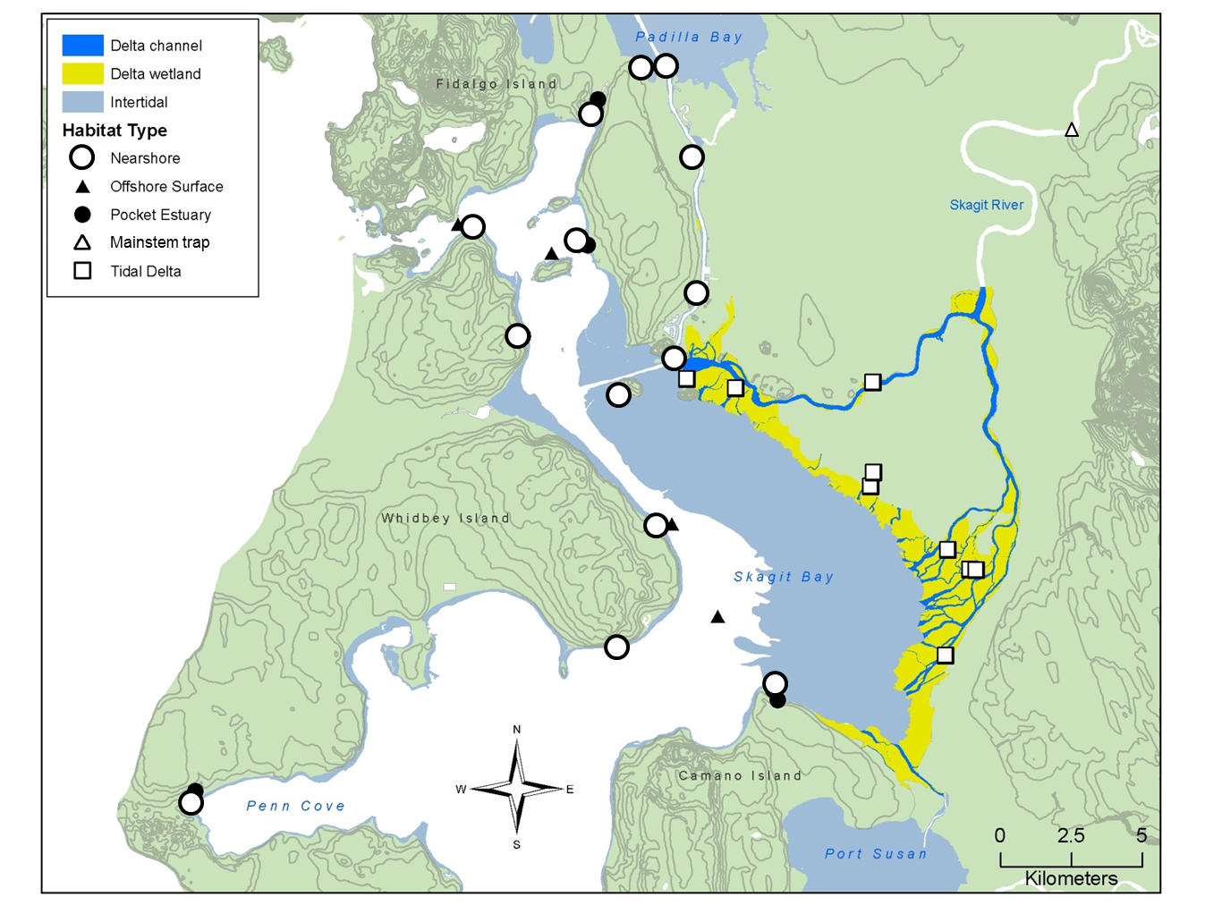

**Figure 2.** Map of the Skagit River (in Northern Puget Sound, WA) mainstem, estuarine tidal delta, and Skagit Bay, with sites sampled by different gear types indicated by different shapes. Squares indicate Fyke net sites, circles (both open and filled) indicate beach seine sites, and filled triangles indicate offshore trawl sampling sites. Only index sites are shown (site which are sampled during every sampling period).

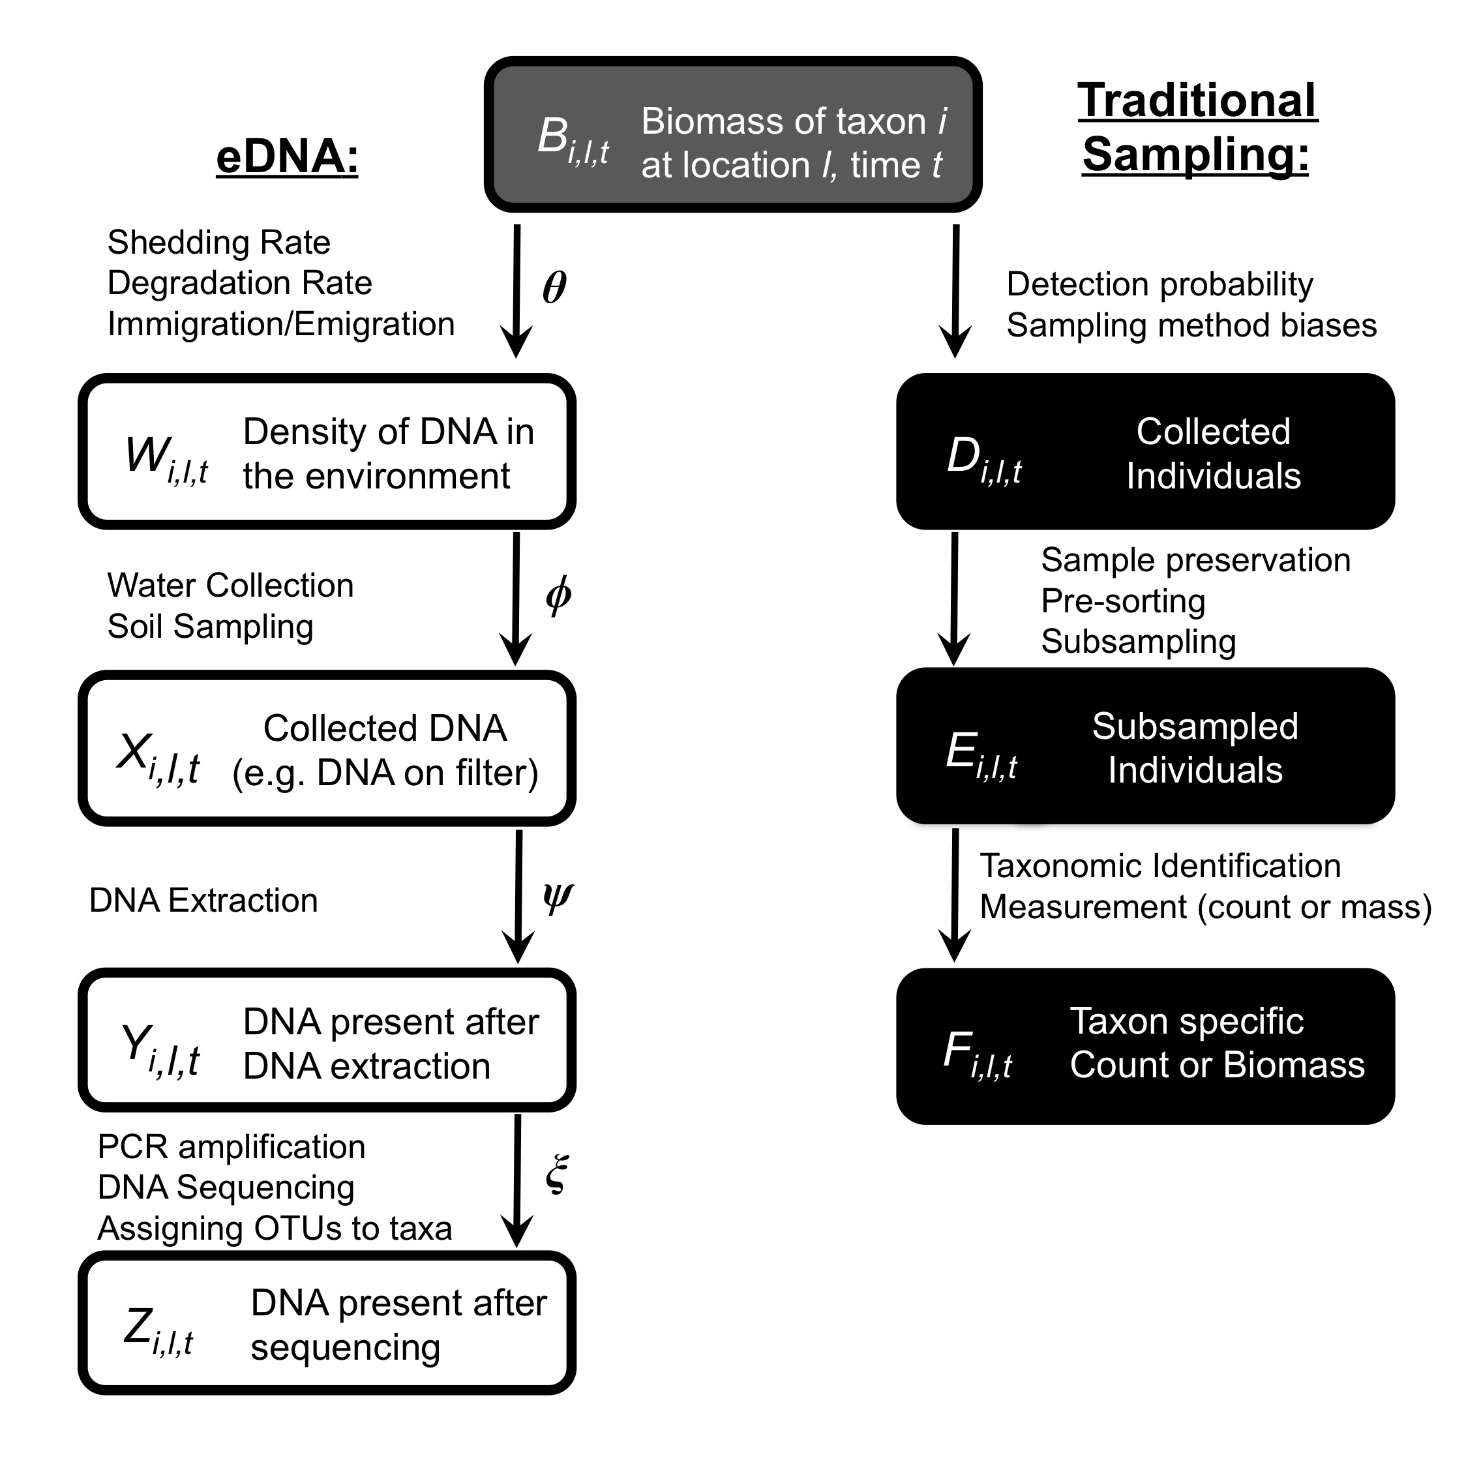

**Figure 3:** A schematic illustration of the process of sampling ecological communities using eDNA and traditional sampling methods. Boxes correspond to latent states, while arrows and greek letters represent process contributing to the transitions between states. While we present only one eDNA path and one traditional sampling path, recognize that there are many potential variations on the form of this figure depending on the details of a particular protocol. Note that the eDNA and traditional sampling branches of this schematic are not directly comparable (there are no arrows that connect white and black boxes). From (*16*).

**18. Curriculum Vitae:**

See supporting documents

**19. Letter of Recommendation**: An optional letter of support from a stock assessment scientist or science director explaining how your proposal has the potential to improve the accuracy, precision, and timely of scientific information for the assessment of living marine resource